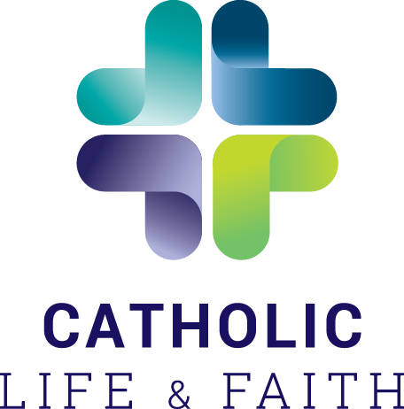
Catholic Life and Faith
Resource Order Form

Books may be ordered with invoice or credit card. Please complete all information below.
Tax and shipping included in prices listed. Email completed order form to: Leisa.clf@gmail.com

Name:

Diocese/Parish:

Mailing Address (City, State/Province/Postal Code:

Email address:

Phone (with area code):

If credit card purchase, card number, expiration date and CVV code (secure site is used):

Resource | Price per book/resource | Quantity
Grateful Disciples English | $15
Grateful Disciples Spanish | $15
Journal | $5
Bridges to Discipleship English | $12.50
Bridges to Discipleship Spanish | $12.50
Bridges to Community | $12.50
Bridges to People | $12.50
Bridges bundle - any 3 Bridges books | $30
Total

